ForEach – Walkthrough

The foreach Repetition Structure

C# provides the foreach repetition structure for iterating through values in data structures, such as arrays

When used with one-dimensional arrays, foreach behaves like a for structure that iterates through the range of indices from 0 to the array’s Length

Instead of a counter, foreach uses a variable to represent the value of each element

The source code below uses the foreach structure to determine the minimum value in a two-dimensional array of grades

We are going to build a basic application which has a single button, which when clicked will:

* Iterate through an array of exam grades using the foreach construct to determine the lowest grade

1. Create a new WPF project
2. Drag across a button from the toolbox
   1. set the “Name” property to btn_Result
   2. set the “Content” property to “Run Program”

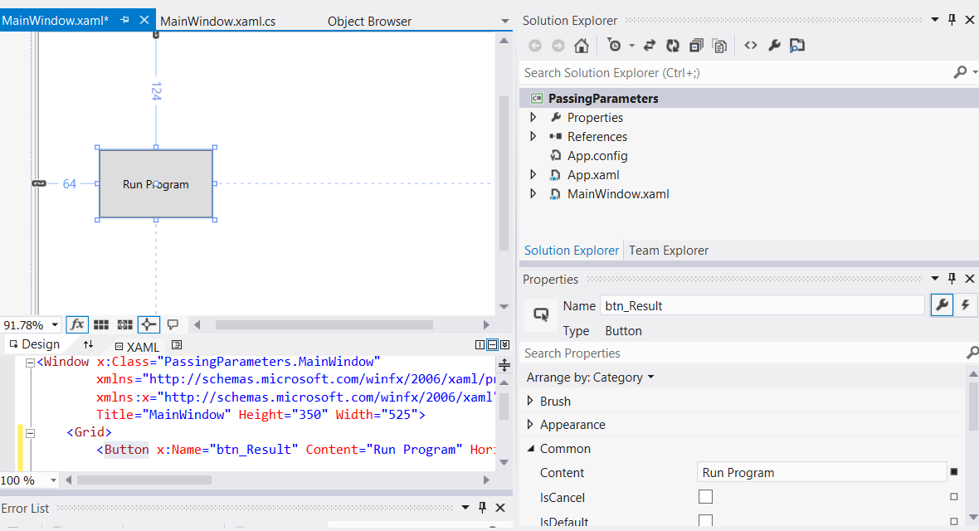

1. Drag across a text block and from the toolbox
   1. set the “Name” property to txtblk_Result
   2. set the “Text” property to blank

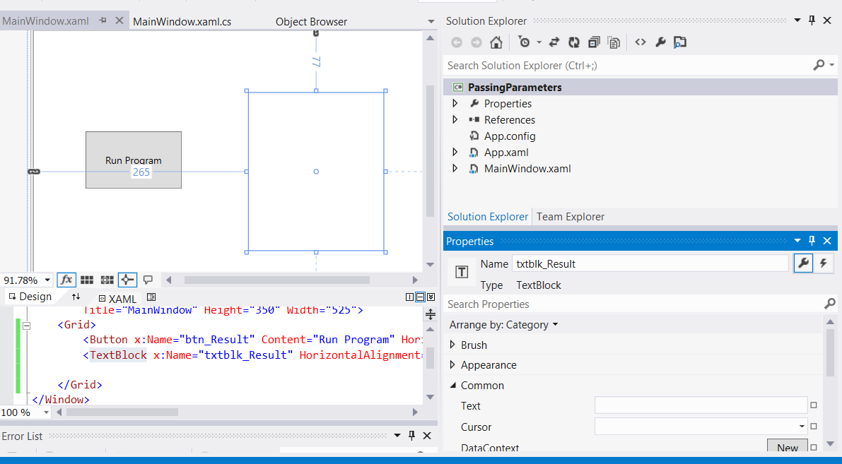

1. Double-click on the “Run Program” button to automatically create an event handler in the MainWindow.xaml.cs file, which is a method called btn_Result_Click

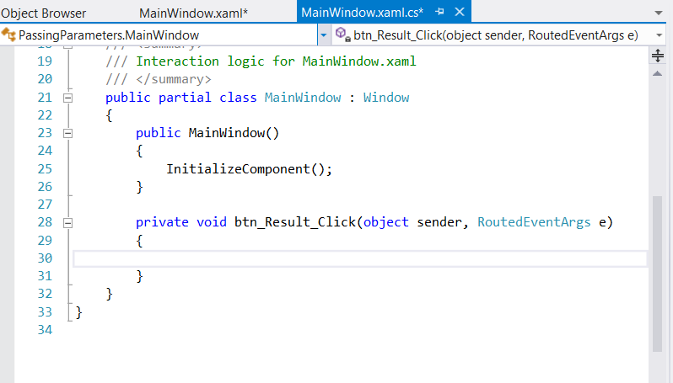

1. We are now going to write the code for this event handler. The final code can be viewed in the screenshot below followed by a full explanation

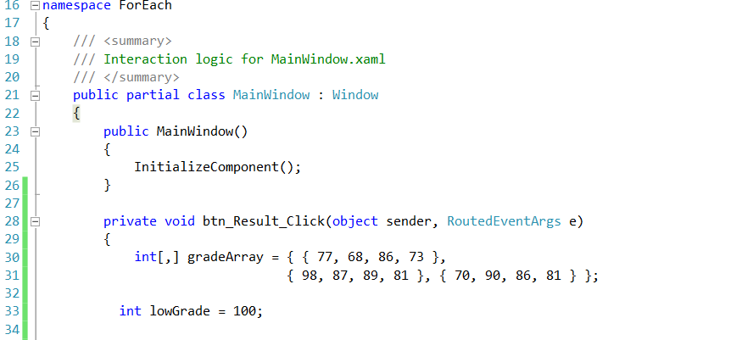

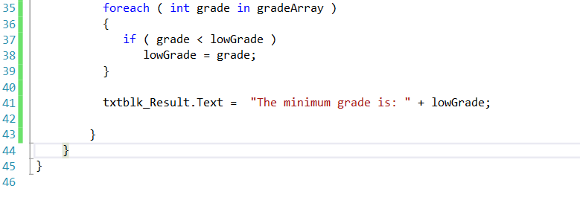

Using foreach with an array - code walkthrough

The header of the foreach structure (line 35) specifies a variable, grade, and an array, gradeArray

The foreach structure iterates through all elements in gradeArray, sequentially assigning each value to variable grade

Line 37 compares each value to variable lowGrade, which stores the lowest grade in the array

For rectangular arrays, the repetition of the foreach structure begins with the element whose indices are all zero, then iterates through all possible combinations of indices, incrementing the rightmost index first

When the rightmost index reaches its upper bound, it is reset to zero, and the index to the left of it is incremented by 1

In this case, grade takes the values as they are ordered in the initializer list in lines

30 - 31

When all the grades have been processed, lowGrade is displayed (line 41)

Although many array calculations are handled best with a counter, foreach is useful when the indices of the elements are not important

The foreach structure is particularly useful for looping through arrays of objects